Climate Change for Non-Capacity Increasing Projects Annotated Outline
GUIDANCE:
Use the information in this outline to complete the Climate Change section in the CEQA chapter of the project’s environmental document. This outline uses the following colors:
- Black text = Required headings.
- Blue text = Instructions and guidance to be considered and deleted from the final document.
- Red text = Required boilerplate text to be inserted into document. This text may be deleted if not applicable but may not be edited.
- Purple text = Example text that can be used in the document, as applicable.

CLIMATE CHANGE
Climate change refers to long-term changes in temperature, precipitation, wind patterns, and other elements of the Earth's climate system. The Intergovernmental Panel on Climate Change, established by the United Nations and World Meteorological Organization in 1988, is devoted to greenhouse gas (GHG) emissions reduction and climate change research and policy. Climate change in the past has generally occurred gradually over millennia, or more suddenly in response to cataclysmic natural disruptions. The research of the Intergovernmental Panel on Climate Change and other scientists over recent decades, however, has unequivocally attributed an accelerated rate of climatological changes over the past 150 years to GHG emissions generated from the production and use of fossil fuels.
Human activities generate GHGs consisting primarily of carbon dioxide (CO₂), methane (CH₄), nitrous oxide (N₂O), tetrafluoromethane, hexafluoroethane, sulfur hexafluoride (SF₆), and various hydrofluorocarbons (HFCs). CO₂ is the most abundant GHG; while it is a naturally occurring and necessary component of Earth’s atmosphere, fossil-fuel combustion is the main source of additional, human-generated CO₂ that is the main driver of climate change. In the U.S. and in California, transportation is the largest source of GHG emissions, mostly CO₂.
The impacts of climate change are already being observed in the form of sea level rise, drought, extended and severe fire seasons, and historic flooding from changing storm patterns. The most important strategy to address climate change is to reduce GHG emissions. Additional strategies are necessary to mitigate and adapt to these impacts. In the context of climate change, “mitigation” involves actions to reduce GHG emissions to lessen adverse impacts that are likely to occur. “Adaptation” is planning for and responding to impacts to reduce vulnerability to harm, such as by adjusting transportation design standards to withstand more intense storms, heat, and higher sea levels. This analysis will include a discussion of both in the context of this transportation project.

Regulatory Setting
For a full list of laws, regulations, and guidance related to climate change (GHGs and adaptation), please refer to Caltrans’ Standard Environmental Reference (SER), Chapter 16, Climate Change.

Federal
To date, no nationwide numeric mobile-source GHG reduction targets have been established, nor have any regulations or legislation been enacted specifically to address climate change and GHG emissions reduction at the project level.
The National Environmental Policy Act (NEPA) (42 United States Code [USC] Part 4332) requires federal agencies to assess the environmental effects of their proposed actions prior to making a decision on the action or project. In January 2023, the White House Council on Environmental Quality (CEQ) issued updated and expanded interim National Environmental Policy Act Guidance on Consideration of Greenhouse Gas Emissions and Climate Change (88 Fed. Reg. 1196) (CEQ NEPA GHG Guidance), in accordance with EO 14057, Catalyzing Clean Energy Industries and Jobs Through Federal Sustainability, 86 FR 70935 (Dec. 13, 2021) and EO 14008, Tackling the Climate Crisis at Home and Abroad. The CEQ guidance does not establish numeric thresholds of significance, but emphasizes quantifying reasonably foreseeable lifetime direct and indirect emissions whenever possible. This guidance also emphasizes resilience and environmental justice in project-level climate change and GHG analyses.
The Federal Highway Administration (FHWA) recognizes the threats that extreme weather, sea level rise, and other changes in environmental conditions pose to valuable transportation infrastructure and those who depend on it. FHWA therefore supports a sustainability approach that assesses vulnerability to climate risks and incorporates resilience into planning, asset management, project development and design, and operations and maintenance practices (FHWA 2022). This approach encourages planning for sustainable highways by addressing climate risks while balancing environmental, economic, and social values— “the triple bottom line of sustainability” (FHWA n.d.). Program and project elements that foster sustainability and resilience also support economic vitality and global efficiency, increase safety and mobility, enhance the environment, promote energy conservation, and improve the quality of life.
Early efforts by the federal government to improve fuel economy and energy efficiency to address climate change and its associated effects include The Energy Policy and Conservation Act of 1975 (42 USC Section 6201); and Corporate Average Fuel Economy (CAFE) Standards. The U.S. Department of Transportation’s National Highway Traffic and Safety Administration (NHTSA) sets and enforces corporate average fuel economy (CAFÉ) standards for on-road motor vehicles sold in the United States. The Environmental Protection Agency (U.S. EPA) calculates average fuel economy levels for manufacturers, and also sets related GHG emissions standards for vehicles under the Clean Air Act. Raising CAFE standards leads automakers to create a more fuel-efficient fleet, which improves our nation’s energy security, saves consumers money at the pump, and reduces GHG emissions (U.S. DOT 2014). These standards are periodically updated and published through the federal rulemaking process.

State
California has been innovative and proactive in addressing GHG emissions and climate change by passing multiple Senate and Assembly bills and executive orders (EOs).
In 2005, EO S-3-05 initially set a goal to reduce California’s GHG emissions to 80 percent below year 1990 levels by 2050, with interim reduction targets. Later EOs and Assembly and Senate bills refined interim targets and codified the emissions reduction goals and strategies. The California Air Resources Board (ARB) was directed to create a climate change scoping plan and implement rules to achieve “real, quantifiable, cost-effective reductions of greenhouse gases.” Ongoing GHG emissions reduction was also mandated in Health and Safety Code (H&SC) Section 38551(b). In 2022, the California Climate Crisis Act was passed, establishing state policy to reduce statewide human- caused GHG emissions by 85 percent below 1990 levels, achieve net zero GHG emissions by 2045, and achieve and maintain negative emissions thereafter.
Beyond GHG reduction, the State maintains a climate adaptation strategy to address the full range of climate change stressors, and passed legislation requiring state agencies to consider protection and management of natural and working lands as an important strategy in meeting the state’s GHG reduction goals.

Environmental Setting
Describe the project location briefly and in general terms, from the perspective of factors that affect transportation GHG emissions, e.g. development density, traffic operations, economy. Use relevant information from the land use, air quality, noise, and traffic analyses sections but do not duplicate all that information. The following examples are meant to provide a template for the discussion; they are not required boilerplate. Customize them to your project location and relevant documents.
The proposed project is in an urban area of XX County with a well-developed road and street network. The project area is mainly residential, with some light industrial and commercial buildings. The route in the project area is heavily used during peak hours. A metropolitan or regional transportation plan (MTP or RTP)/sustainable communities strategy (SCS) by [MPO or RTPA] guides transportation development in the project area. The XX County General Plan Sustainability element addresses GHGs in the project area.
OR
The proposed project is in a rural area, with a primarily natural-resources based agricultural and tourism economy. SR-## is the main transportation route to and through the area for both passenger and commercial vehicles. The nearest alternate route is SR-##, twelve miles to the east. Traffic counts are low. Railroad tracks running parallel to SR-## right-of-way carry several passenger and freight trains each day. The XXX Regional Transportation Agency guides transportation development. The XX County General Plan Circulation, Safety, and Traffic elements address GHGs in the project area.

GHG Inventories
A GHG emissions inventory estimates the amount of GHGs discharged into the atmosphere by specific sources over a period of time. Tracking annual GHG emissions allows countries, states, and smaller jurisdictions to understand how emissions are changing and what actions may be needed to attain emission reduction goals. U.S. EPA is responsible for documenting GHG emissions nationwide, and the ARB does so for the state of California, as required by H&SC Section 39607.4. Cities and other local jurisdictions may also conduct local GHG inventories to inform their GHG reduction or climate action plans.
[Inventory data and figures will be updated as each year’s federal and state inventory is published. Confirm the latest version is included in the document.]

National GHG Inventory
The annual GHG inventory submitted by the U.S. EPA to the United Nations provides a comprehensive accounting of all human-produced sources of GHGs in the United States. Total national GHG emissions from all sectors in 2021 were 5,586.0 million metric tons (MMT), factoring in deductions for carbon sequestration in the land sector. (Land Use, Land Use Change, and Forestry provide a carbon sink equivalent to 12% of total U.S. emissions in 2021 [U.S. EPA 2023a].) While total GHG emissions in 2021 were 17% below 2005 levels, they increased by 6% over 2020 levels. Of these, 79.4% were CO₂, 11.5% were CH₄, and 6.2% were N₂O; the balance consisted of fluorinated gases. From 1990 to 2021, CO₂ emissions decreased by only 2% (U.S. EPA 2023a).
The transportation sector’s share of total GHG emissions increased to 28% in 2021 and remains the largest contributing sector (Figure ##-#). Transportation fossil fuel combustion accounted for 92% of all CO₂ emissions in 2021. This is an increase of 7% over 2020, largely due to the rebound in economic activity following the COVID-19 pandemic (U.S. EPA 2023a, 2023b)). [Authors: Remember to add figure numbers to figure titles and text references. Remove this blue instruction.]
Figure ##. U.S. 2021 Greenhouse Gas Emissions
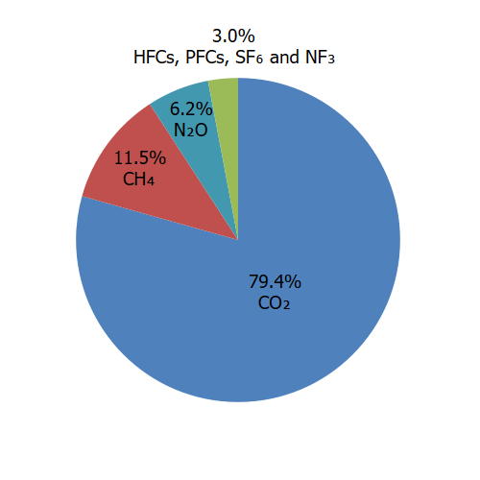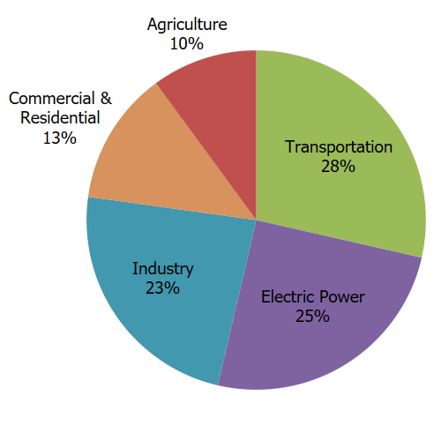
(Source: U.S. EPA 2023b)

State GHG Inventory
ARB collects GHG emissions data for transportation, electricity, commercial/residential, industrial, agricultural, and waste management sectors each year. It then summarizes and highlights major annual changes and trends to demonstrate the state’s progress in meeting its GHG reduction goals. Overall statewide GHG emissions declined from 2000 to 2020 despite growth in population and state economic output (Figure #) (ARB 2022a).
Figure ##. California 2020 Greenhouse Gas Emissions by Economic Sector
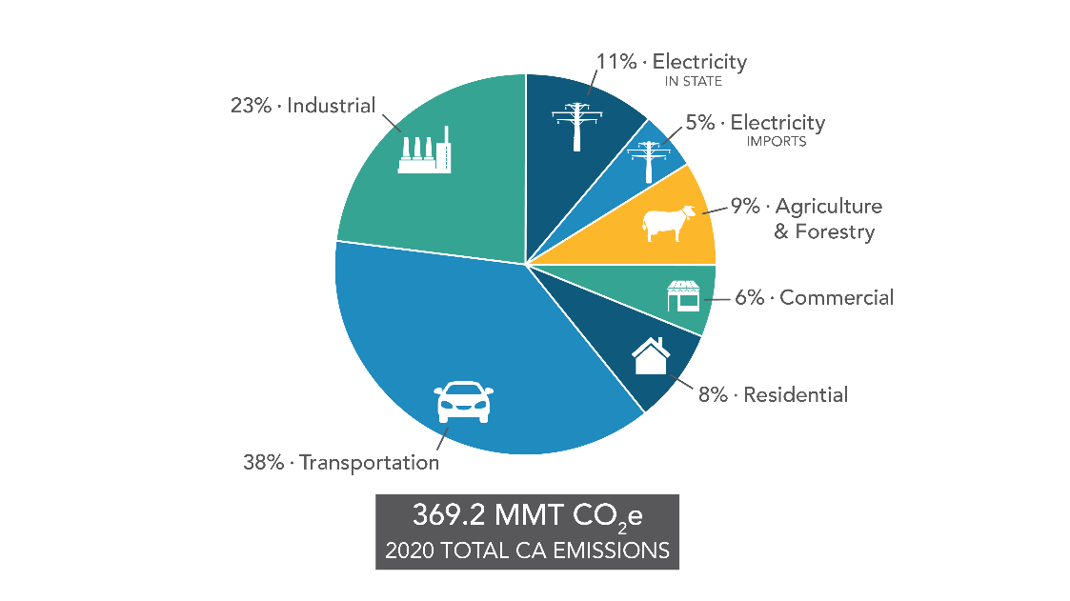
(Source: ARB 2022a)

Figure ##. Change in California GDP, Population, and GHG Emissions since 2000
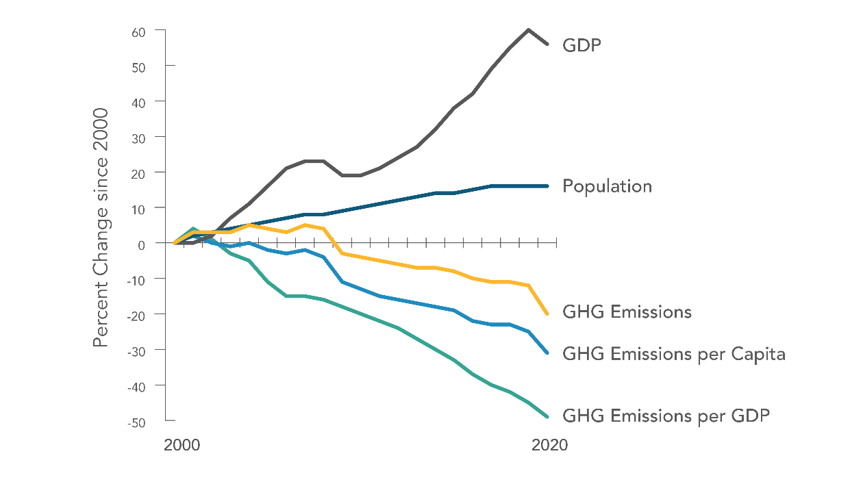
(Source: ARB 2022a)

AB 32 required ARB to develop a Scoping Plan that describes the approach California will take to achieve the goal of reducing GHG emissions to 1990 levels by 2020, and to update it every 5 years. The AB 32 Scoping Plan and the subsequent updates contain the main strategies California will use to reduce GHG emissions. ARB adopted the first scoping plan in 2008. The second updated plan, California’s 2017 Climate Change Scoping Plan, adopted on December 14, 2017, reflects the 2030 target established in EO B-30-15 and SB 32. The 2022 Scoping Plan for Achieving Carbon Neutrality, adopted September 2022, assesses progress toward the statutory 2030 reduction goal and defines a path to reduce human-caused emissions to 85 percent below 1990 levels and achieve carbon neutrality no later than 2045, in accordance with AB 1279 (ARB 2022b).

Regional Plans
As required by The Sustainable Communities and Climate Protection Act of 2008, ARB sets regional GHG reduction targets for California’s 18 metropolitan planning organizations (MPOs) to achieve through planning future projects that will cumulatively achieve those goals, and reporting how they will be met in the Regional Transportation Plan/Sustainable Communities Strategy (RTP/SCS). Targets are set at a percent reduction of passenger vehicle GHG emissions per person from 2005 levels. The proposed project is included in the RTP/SCS for [Identify the applicable MPO for the region in which the proposed project is located.] The regional reduction target for [MPO] is XX percent by 2035 (ARB 2021). [Identify the most recent GHG reduction targets for 2035, found at https://ww2.arb.ca.gov/our-work/programs/sustainable-communities-program/regional-plan-targets.]
For projects in areas outside MPOs that do not have Sustainable Communities Strategies: The regional transportation planning agency (RTPA) RTP, or local climate action plan, greenhouse gas reduction plan, or general plan element may contain GHG related goals and plans. Describe or list transportation-related policies and/or goals in these plans. Examine them to establish whether the proposed project conflicts with an applicable plan, policy or regulation adopted for the purpose of reducing the emissions of GHGs. Climate action plans can be found at California Climate Adaptation Portal interactive map: https://webmaps.arb.ca.gov/capmap/.
Example text for non-MPO locations (revise as appropriate):
The project area is not within the jurisdiction of an MPO and therefore not subject to ARB GHG reduction targets. However, the [name of local transportation planning commission or agency] is the regional transportation planning agency (RTPA) for the project area. The XXX [YEAR] RTP identifies [discuss RTPA project types or goals for GHG reductions.]
For MPOs, RTPAs, and smaller jurisdictions, include a brief description of any local climate action plan or other adopted GHG reduction plan for the proposed project area. List the plans and relevant policies or goals in a table similar to the example below. Optionally, for simple or non-capacity increasing projects, a paragraph with a few examples of GHG reduction or transportation related energy-efficiency goals or policies from each adopted plan is sufficient. Remember to search for and include climate actions plans or GHG reduction plans where available.
All plans cited in text or the table should be included in the References list at the end of this chapter.
Table ##. Regional and Local Greenhouse Gas Reduction Plans
Title | GHG Reduction Policies or Strategies
Association of Monterey Bay Area Governments (AMBAG) 2040 Metropolitan Transportation Plan/Sustainable Communities Strategy and Regional Transportation Plans for Monterey, San Benito, and Santa Cruz Counties (adopted June 2018) | - Integrated multi-modal network  - Expand the public transit network  - Strategic capacity and technology enhancements to existing highways  - Identify a list of projects that will add and enhance walking and biking facilities  - Transportation Systems Management measures  - Transportation Demand Management
City of Gonzales Climate Action Plan (adopted February 2013) | Measure CP-22-N: Bike Lane Program
Gonzales 2010 General Plan (adopted January 2011) | Sustainability Element

Project Analysis
GHG emissions from transportation projects can be divided into those produced during operation and use of the State Highway System (SHS) (operational emissions) and those produced during construction. The primary GHGs produced by the transportation sector are CO₂, CH₄, N₂O, and HFCs. CO₂ emissions are a product of burning gasoline or diesel fuel in internal combustion engines, along with relatively small amounts of CH₄ and N₂O. A small amount of HFC emissions related to refrigeration is also included in the transportation sector. (GHGs differ in how much heat each traps in the atmosphere, called global warming potential, or GWP. CO₂ is the most important GHG, so amounts of other gases are expressed relative to CO₂, using a metric called “carbon dioxide equivalent”, or CO₂e. The global warming potential of CO₂ is assigned a value of 1, and the GWP of other gases is assessed as multiples of CO₂.)
The CEQA Guidelines generally address greenhouse gas emissions as a cumulative impact due to the global nature of climate change (Pub. Resources Code, § 21083(b)(2)). As the California Supreme Court explained, “because of the global scale of climate change, any one project's contribution is unlikely to be significant by itself.” (Cleveland National Forest Foundation v. San Diego Assn. of Governments (2017) 3 Cal.5th 497, 512.) In assessing cumulative impacts, it must be determined if a project’s incremental effect is “cumulatively considerable” (CEQA Guidelines Sections 15064(h)(1) and 15130).
To make this determination, the incremental impacts of the project must be compared with the effects of past, current, and probable future projects. Although climate change is ultimately a cumulative impact, not every individual project that emits greenhouse gases must necessarily be found to contribute to a significant cumulative impact on the environment.

Operational Emissions
Non-Capacity-Increasing Projects
Perform a qualitative analysis of operational emissions. Project type should be determined early in the project development process and should support the purpose and need of the project. If a non-capacity-increasing project is controversial or includes other features that could increase GHG emissions, conduct a quantitative GHG analysis using EMFAC as described in the annotated outline for capacity-increasing projects. Discuss this with the PDT.
For non-capacity increasing projects, include a qualitative discussion (example text provided below) about the operation of the project and the low to no potential for an increase in operational GHG emissions. Acknowledge (as discussed below) that construction emissions will be unavoidable but that there will likely be long-term GHG benefits from improved operation and smoother pavement surfaces, as applicable. Remember that the purpose of a project is to solve a problem (e.g., to improve pavement condition to preserve and extend the service life). If the project is a ramp metering or signalization project, provide a discussion of what traffic-smoothing effects the project will have; to the extent that the signal or meter provides a smoother traffic flow, there will likely be an overall reduction in GHGs emitted.
EXAMPLE TEXT: modify for your project
The purpose of the proposed project is to (XXX) and will not increase the vehicle capacity of the roadway. This type of project generally causes minimal or no increase in operational GHG emissions. Because the project would not increase the number of travel lanes on [route or location], no increase in vehicle miles traveled (VMT) would occur. While some GHG emissions during the construction period would be unavoidable, no increase in operational GHG emissions is expected.

Construction Emissions
Construction GHG emissions would result from material processing and transportation, on-site construction equipment, and traffic delays due to construction. These emissions will be produced at different levels throughout the construction phase; their frequency and occurrence can be reduced through innovations in plans and specifications and by implementing better traffic management during construction phases. While construction GHG emissions are only produced for a short time, they have long-term effects in the atmosphere, so cannot be considered “temporary” in the same way as criteria pollutants that subside after construction is completed.
Use of long-life pavement, improved traffic management plans, and changes in materials can also help offset GHG emissions produced during construction by allowing longer intervals between maintenance and rehabilitation activities.
GHG emissions related to anticipated construction activities shall be calculated for all projects. Using a readily available model such as the Sacramento Metropolitan Air Quality Management District Road Construction Emissions Model OR the Caltrans Construction Emissions Tool (CAL-CET) to quantify the expected construction-related GHG emissions related to the proposed project. Include the calculation results in a brief sentence or two stating the expected construction duration and the total expected GHG emissions for the construction period.
Standard conditions and best management practices to reduce or eliminate construction GHG emissions must be included in EVERY project. Consult the GHG Reduction Measures Toolbox for Internal Use in Caltrans Project Development at https://env.onramp.dot.ca.gov/downloads/env/managedfiles/caltrans-ghg-reduction-measures-jun-2021-a11y.pdf or contact HQ Climate Change Representative for suggested GHG reduction measures.
IMPORTANT: Rewrite suggested measures as environmental commitments that can be implemented and verified at project closeout (“biddable and buildable” actions). For example: “Caltrans will …” “The contractor(s) will…” “The project will include …”.
Verify any proposed measures with the PDT. Record the agreed-upon measures in the environmental commitments record or district equivalent. If the list is lengthy, present them under “Project Level GHG Reduction Strategies” heading and use the example paragraph below in this section.
Discuss any specifications or construction measures included in the project that will contribute to reducing construction GHG emissions here. These can include Standard Specifications, Standard Special Provisions, Nonstandard Special Provisions, project-specific construction-emissions reduction measures, and measures from other resource topics that help reduce construction GHG emissions.
For example:
All construction contracts include Caltrans Standard Specifications related to air quality. Section 7-1.02A and 7 1.02C, Emissions Reduction, requires contractors to comply with all laws applicable to the project and to certify they are aware of and will comply with all ARB emission reduction regulations. Section 14-9.02, Air Pollution Control, requires contractors to comply with all air pollution control rules, regulations, ordinances, and statutes. Certain common regulations, such as equipment idling restrictions, that reduce construction vehicle emissions also help reduce GHG emissions.

CEQA Conclusion
CEQA significance determinations for GHGs are required. Consult Caltrans’ Interim Guidance: Determining CEQA Significance for Greenhouse Gas Emissions for Projects on the State Highway System (2019), posted on the Caltrans intranet at https://env.onramp.dot.ca.gov/downloads/env/managedfiles/emo-caltrans-ceqa-ghg-interim-guidance.pdf. If you do not have intranet access, contact your District generalist or HQ DEA Climate Change Representative for a copy of the guidance.
Make a determination for both CEQA questions. Would the project:
- Generate greenhouse gas emissions, either directly or indirectly, that may have a significant impact on the environment?
- Conflict with an applicable plan, policy or regulation adopted for the purpose of reducing the emissions of greenhouse gases?
Summarize this conclusion in CEQA section 3.2.8 Greenhouse Gas Emissions. Ensure both discussions are consistent.
Caltrans is firmly committed to implementing measures to help reduce GHG emissions. These measures are outlined in the following section.
For projects for which the Department is the CEQA and/or NEPA lead agency, please send a PDF of the environmental document you are working on and a Microsoft Word version of the Climate Change section or memo, along with your request for a review, directly to your designated District climate change reviewer. Consultants should submit to the Caltrans project generalist. The contact list of District reviewers can be found at https://env.onramp.dot.ca.gov/downloads/env/managedfiles/emo-distrct-climate-change-review-contacts.pdf. Discuss a feasible review schedule with your reviewer.
For projects where Caltrans is not the CEQA lead agency, the CEQA lead agency must conduct its own analysis and make its own CEQA determinations for GHG emissions, reduction measures, and mitigation. The write-up should include the methods and policies of the lead agency, and not those of Caltrans unless the local agency has adopted them as their own. For reviews of oversight projects when Caltrans is not the CEQA lead, apply the same standards, but our comments are only advisory.

Greenhouse Gas Reduction Strategies

Statewide Efforts
In response to Assembly Bill 32, the Global Warming Solutions Act, California is implementing measures to achieve emission reductions of GHGs that cause climate change. Climate change programs in California are effectively reducing GHG emissions from all sectors of the economy. These programs include regulations, market programs, and incentives that will transform transportation, industry, fuels, and other sectors to take California into a sustainable, cleaner, low-carbon future, while maintaining a robust economy (ARB 2022c).
Major sectors of the California economy, including transportation, will need to reduce emissions to meet 2030 and 2050 GHG emissions targets. The Governor’s Office of Planning and Research identified five sustainability pillars in a 2015 report: (1) Increasing the share of renewable energy in the State’s energy mix to at least 50 percent by 2030; (2) Reducing petroleum use by up to 50 percent by 2030; (3) Increasing the energy efficiency of existing buildings by 50 percent by 2030; (4) Reducing emissions of short-lived climate pollutants; and (5) Stewarding natural resources, including forests, working lands, and wetlands, to ensure that they store carbon, are resilient, and enhance other environmental benefits (OPR 2015).
The transportation sector is integral to the people and economy of California. To achieve GHG emission reduction goals, it is vital that the state build on past successes in reducing criteria and toxic air pollutants from transportation and goods movement. GHG emission reductions will come from cleaner vehicle technologies, lower-carbon fuels, and reduction of vehicle miles traveled (VMT). Reducing today’s petroleum use in cars and trucks is a key state goal for reducing greenhouse gas emissions by 2030 (California Environmental Protection Agency 2015).
In addition, SB 1386 (Wolk 2016) established as state policy the protection and management of natural and working lands and requires state agencies to consider that policy in their own decision making. Trees and vegetation on forests, rangelands, farms, and wetlands remove carbon dioxide from the atmosphere through biological processes and sequester the carbon in above- and below-ground matter.
Subsequently, Governor Gavin Newsom issued Executive Order N-82-20 to combat the crises in climate change and biodiversity. It instructs state agencies to use existing authorities and resources to identify and implement near- and long-term actions to accelerate natural removal of carbon and build climate resilience in our forests, wetlands, urban greenspaces, agricultural soils, and land conservation activities in ways that serve all communities and in particular low-income, disadvantaged, and vulnerable communities. To support this order, the California Natural Resources Agency released Natural and Working Lands Climate Smart Strategy (California Natural Resources Agency 2022).

Caltrans Activities
Caltrans continues to be involved on the Governor’s Climate Action Team as the ARB works to implement EOs S-3-05 and S-01-07 and help achieve the targets set forth in AB 32. EO B-30-15, issued in April 2015, and SB 32 (2016), set an interim target to cut GHG emissions to 40 percent below 1990 levels by 2030. The following major initiatives are underway at Caltrans to help meet these targets.

Climate Action Plan for Transportation Infrastructure
The California Action Plan for Transportation Infrastructure (CAPTI) builds on executive orders signed by Governor Newsom in 2019 and 2020 targeted at reducing GHG emissions in transportation, which account for more than 40 percent of all polluting emissions, to reach the state's climate goals. Under CAPTI, where feasible and within existing funding program structures, the state will invest discretionary transportation funds in sustainable infrastructure projects that align with its climate, health, and social equity goals (California State Transportation Agency 2021).

California Transportation Plan
The California Transportation Plan (CTP) is a statewide, long-range transportation plan to meet our future mobility needs and reduce GHG emissions. It serves as an umbrella document for all the other statewide transportation planning documents. The CTP 2050 presents a vision of a safe, resilient, and universally accessible transportation system that supports vibrant communities, advances racial and economic justice, and improves public and environmental health. The plan’s climate goal is to achieve statewide GHG emissions reduction targets and increase resilience to climate change. It demonstrates how GHG emissions from the transportation sector can be reduced through advancements in clean fuel technologies; continued shifts toward active travel, transit, and shared mobility; more efficient land use and development practices; and continued shifts to telework (Caltrans 2021a).

Caltrans Strategic Plan
The Caltrans 2020–2024 Strategic Plan includes goals of stewardship, climate action, and equity. Climate action strategies include developing and implementing a Caltrans Climate Action Plan; a robust program of climate action education, training, and outreach; partnership and collaboration; a VMT monitoring and reduction program; and engaging with the most vulnerable communities in developing and implementing Caltrans climate action activities (Caltrans 2021b).

Caltrans Policy Directives and Other Initiatives
Caltrans Director’s Policy 30 (DP-30) Climate Change (June 22, 2012) established a policy to ensure coordinated efforts to incorporate climate change into Caltrans decisions and activities. Other Director’s policies promote energy efficiency, conservation, and climate change, and commit Caltrans to sustainability practices in all planning, maintenance, and operations. Caltrans Greenhouse Gas Emissions and Mitigation Report (Caltrans 2020) provides a comprehensive overview of Caltrans’ emissions and current Caltrans procedures and activities that track and reduce GHG emissions. It identifies additional opportunities for further reducing GHG emissions from Department-controlled emission sources, in support of Caltrans and State goals.

Project-Level GHG Reduction Strategies
The following measures will also be implemented in the project to reduce GHG emissions and potential climate change impacts from the project.
In accordance with the memo Significance and Mitigation under the California Environmental Quality Act (November 2016) identify and list all feasible measures to reduce GHG emissions from operations and construction.
Include appropriate measures from other resource topics, such as air quality, transportation, aesthetics, and biology (revegetation measures can co-benefit GHG reduction). Also review mitigation measures recommended in the EIR for the applicable RTP and the GHG Reduction Measures Toolbox for Internal Use in Caltrans Project Development at https://env.onramp.dot.ca.gov/downloads/env/managedfiles/caltrans-ghg-reduction-measures-jun-2021-a11y.pdf. If you do not have intranet access, contact your District generalist or HQ DEA Climate Change Representative for a copy of the toolbox.
Select actions that are suitable for the scope of the project and modify them as needed. Verify with the PDT that they are feasible and rewrite them as definitive commitments. These measures shall be carried forward to the environmental commitment record or district equivalent.

Adaptation
Reducing GHG emissions is only one part of an approach to addressing climate change. Caltrans must plan for the effects of climate change on the state’s transportation infrastructure and strengthen or protect the facilities from damage. Climate change is expected to produce increased variability in precipitation, rising temperatures, rising sea levels, variability in storm surges and their intensity, and in the frequency and intensity of wildfires. Flooding and erosion can damage or wash out roads; longer periods of intense heat can buckle pavement and railroad tracks; storm surges combined with a rising sea level can inundate highways. Wildfire can directly burn facilities and indirectly cause damage when rain falls on denuded slopes that landslide after a fire. Effects will vary by location and may, in the most extreme cases, require that a facility be relocated or redesigned. Furthermore, the combined effects of transportation projects and climate stressors can exacerbate the impacts of both on vulnerable communities in a project area. Accordingly, Caltrans must consider these types of climate stressors in how highways are planned, designed, built, operated, and maintained.

Federal Efforts
Under NEPA Assignment, Caltrans is obligated to comply with all applicable federal environmental laws and FHWA NEPA regulations, policies, and guidance. Caltrans practices generally align with the 2023 CEQ interim Guidance on Consideration of Greenhouse Gas Emissions and Climate Change, which offers recommendations for additional ways of evaluating project effects related to GHG emissions and climate change. These recommendations are not regulatory requirements.
The Fifth National Climate Assessment, published in 2023, presents the most recent science and “analyzes the effects of global change on the natural environment, agriculture, energy production and use, land and water resources, transportation, human health and welfare, human social systems, and biological diversity; [It] analyzes current trends in global change, both human-induced and natural, and projects major trends for the subsequent 25 to 100 years … to support informed decision-making across the United States.” Building on previous assessments, it continues to advance “an inclusive, diverse, and sustained process for assessing and communicating scientific knowledge on the impacts, risks, and vulnerabilities associated with a changing global climate” (U.S. Global Change Research Program 2023).
The U.S. Department of Transportation recognizes the transportation sector’s major contribution of GHGs that cause climate change and has made climate action one of the department’s top priorities (U.S. DOT 2023). FHWA’s policy is to strive to identify the risks of climate change and extreme weather events to current and planned transportation systems. FHWA has developed guidance and tools for transportation planning that fosters resilience to climate effects and sustainability at the federal, state, and local levels (FHWA 2022).
The National Oceanic and Atmospheric Administration provides sea level rise projections for all U.S. coastal waters to help communities and decision makers assess their risk from sea level rise. Updated projections through 2150 were released in 2022 in a report and online tool (NOAA 2022).

State Efforts
Climate change adaptation for transportation infrastructure involves long-term planning and risk management to address vulnerabilities in the transportation system. A number of state policies and tools have been developed to guide adaptation efforts.
California’s Fourth Climate Change Assessment (Fourth Assessment) (2018) provides information to help decision makers across sectors and at state, regional, and local scales protect and build the resilience of the state’s people, infrastructure, natural systems, working lands, and waters. The Fourth Assessment reported that if no measures are taken to reduce GHG emissions by 2021 or sooner, the state is projected to experience an up to 8.8 degrees Fahrenheit increase in average annual maximum daily temperatures; a two-thirds decline in water supply from snowpack resulting in water shortages; a 77% increase in average area burned by wildfire; and large-scale erosion of up to 67% of Southern California beaches due to sea level rise. These effects will have profound impacts on infrastructure, agriculture, energy demand, natural systems, communities, and public health (State of California 2018).
Sea level rise is a particular concern for transportation infrastructure in the coastal zone. Major urban airports will be at risk of flooding from sea level rise combined with storm surge as early as 2040; San Francisco airport is already at risk. Miles of coastal highways vulnerable to flooding in a 100-year storm event will triple to 370 by 2100, and 3,750 miles will be exposed to temporary flooding. The Fourth Assessment’s findings highlight the need for proactive action to address these current and future impacts of climate change.
To help actors throughout the state address the findings of California’s Fourth Climate Change Assessment, AB 2800’s multidisciplinary Climate-Safe Infrastructure Working Group published Paying it Forward: The Path Toward Climate-Safe Infrastructure in California. This report provides guidance on assessing risk in the face of inherent uncertainties still posed by the best available climate change science. It also examines how state agencies can use infrastructure planning, design, and implementation processes to respond to the observed and anticipated climate change impacts (Climate-Safe Infrastructure Working Group 2018).
EO S-13-08, issued in 2008, directed state agencies to consider sea level rise scenarios for 2050 and 2100 during planning to assess project vulnerabilities, reduce risks, and increase resilience to sea level rise. It gave rise to the 2009 California Climate Adaptation Strategy, the Safeguarding California Plan, and a series of technical reports on statewide sea level rise projections and risks, including the State of California Sea-Level Rise Guidance Update in 2018. The reports addressed the full range of climate change impacts and recommended adaptation strategies. The current California Climate Adaptation Strategy incorporates key elements of the latest sector-specific plans such as the Natural and Working Lands Climate Smart Strategy, Wildfire and Forest Resilience Action Plan, Water Resilience Portfolio, and the CAPTI (described above). Priorities in the 2023 California Climate Adaptation Strategy include acting in partnership with California Native American Tribes, strengthening protections for climate-vulnerable communities that lack capacity and resources, implementing nature-based climate solutions, using best available climate science, and partnering and collaboration to best leverage resources (California Natural Resources Agency 2023).
EO B-30-15 recognizes that effects of climate change threaten California’s infrastructure and requires state agencies to factor climate change into all planning and investment decisions. Under this EO, the Office of Planning and Research published Planning and Investing for a Resilient California: A Guidebook for State Agencies, to encourage a uniform and systematic approach to building resilience.
SB 1 Coastal Resources: Sea Level Rise (Atkins 2021) established statewide goals to “anticipate, assess, plan for, and, to the extent feasible, avoid, minimize, and mitigate the adverse environmental and economic effects of sea level rise within the coastal zone.” As the legislation directed, the Ocean Protection Council collaborated with 17 state planning and coastal management agencies to develop the State Agency Sea-Level Rise Action Plan for California in February 2022. This plan promotes coordinated actions by state agencies to enhance California's resilience to the impacts of sea level rise (California Ocean Protection Council 2022).

Caltrans Adaptation Efforts

Caltrans Vulnerability Assessments
Caltrans completed climate change vulnerability assessments to identify segments of the State Highway System vulnerable to climate change effects of precipitation, temperature, wildfire, storm surge, and sea level rise.
The climate change data in the assessments were developed in coordination with climate change scientists and experts at federal, state, and regional organizations at the forefront of climate science. The findings of the vulnerability assessments guide analysis of at-risk assets and development of Adaptation Priority Reports as a method to make capital programming decisions to address identified risks.

Caltrans Sustainability Programs
The Director’s Office of Equity, Sustainability and Tribal Affairs supports implementation of sustainable practices at Caltrans. The Sustainability Roadmap is a periodic progress report and plan for meeting the Governor’s sustainability goals related to EOs B-16-12, B-18-12, and B-30-15. The Roadmap includes designing new buildings for climate change resilience and zero-net energy, and replacing fleet vehicles with zero-emission vehicles (Caltrans 2023).

Project Adaptation Analysis
The adaptation analysis is intended to demonstrate how the project will be adapted or resilient to climate change effects. EO B-30-15 requires that all projects consider future climate conditions in the planning and design decisions. Consider how future changes in sea level rise, precipitation and flooding, wildfire, and temperature could affect the project, and what project features, minimization or mitigation measures, and standard practices and specifications will protect the asset or reduce the long-term risk to the finished project.
Consider timeframe, adaptive capacity, and risk tolerance. Refer to guidance in Planning and Investing for a Resilient California: A Guidebook for State Agencies for the process of climate risk analysis, summarized below. (The guidebook can be found at this link: ICARP Climate Services - Office of Planning and Research).
- Work with the PDT to identify how climate change could affect a project or plan.
  - Identify impacts of concern (consider project purpose, design life, location, environmental and community contexts)
  - Assess the scale, scope, and context of climate disruption (e.g., vulnerability and adaptive capacity, nature of the risk, severity of impacts, economic consequences).
- Conduct an analysis of climate risks
  - Select climate change scenarios for analysis (low, medium-high, high GHG emissions).
  - Select an analytical approach based on characteristics of risks identified in Step 1.
- Make a climate-informed decision
  - Evaluate alternatives or design (consider natural infrastructure and integrated solutions that reduce GHG emissions, adapt to impacts, or achieve both. Consider climate impacts throughout project life).
  - Apply resilient decision principles (including solutions that promote equity and foster community resilience).
- Track and monitor progress
  - Develop and evaluate metrics to track progress.
  - Adjust as needed.
Review the climate change vulnerability assessment (https://dot.ca.gov/programs/‌transportation-planning/division-of-transportation-planning/air-quality-and-climate-change/2019-climate-change-vulnerability-assessments) and adaptation priorities reports (https://dot.ca.gov/programs/transportation-planning/division-of-transportation-planning/air-quality-and-climate-change/2020-adaptation-priorities-reports) completed for your district. You may use that information to assess whether your project may be subject to climate change effects. These reports contain information on various climate stressors specific to the district. Include brief information on all the identified stressors that may be applicable to your project; there is no need to replicate all text from the assessments.
Consult general plans, land use plans, RTPs, and local adaptation plans that may also offer strategies that can be incorporated in specific projects.
The environmental document should disclose if a project would exacerbate the effects of climate change related to CEQA topics such as sea level rise, riverine flooding, hazards, and wildfire.
Acknowledge that climate-change risk analysis involves uncertainties as to the timing and intensity of potential risks, although the analysis uses the best available science. Uncertainties may be documented in the project risk register. For example, if a protective design feature is not implemented in the project, the future consequence may be failure of the asset or system. Also consider the risks of project delays if Coastal Commission or other agency permits are delayed because the project does not adequately address coastal impacts.

Sea Level Rise
The Caltrans DEA GIS Library integrates data from multiple sea level rise viewers, with the additional functionality of a post mile tool to pinpoint project locations. This and other visualization tools allow users to identify potential climate change risks in specific geographic areas throughout the state. Individual sea level rise viewers and resources listed below may provide additional insights or capabilities. DED preparers without access to the DEA GIS library may use the individual tools.
  - DEA GIS Library and Caltrans Coastal Program.
  - Caltrans Vulnerability Assessment interactive maps.
  - NOAA SLR viewer (https://coast.noaa.gov/slr/) or Sea Level Rise Scenario tool (https://sealevel.nasa.gov/task-force-scenario-tool).
  - Our Coast Our Future hazard map (https://ourcoastourfuture.org/hazard-map/). TIP: The Our Coast Our Future tool can also show extent of storm surge, wave run-up, flood duration, and minimum/maximum flooding for each SLR scenario.
  - Cal-Adapt website (http://cal-adapt.org/tools/slr-calflod-3d/)
  - District 4 should also use the BCDC “Adapting to Rising Tides” (ART) tool, Bay Shoreline Flood Explorer: explorer.adaptingtorisingtides.org/home
Establish if your project is within a coastal jurisdiction or subject to sea level rise.
If the project is well outside the Coastal Zone and not otherwise expected to be directly affected be sea level rise (i.e. outside the Sacramento-San Joaquin River Delta), you may include the following:
The proposed project is outside the coastal zone and not in an area subject to sea level rise. Accordingly, direct impacts to transportation facilities due to projected sea level rise are not expected.
Create a visual showing that the project is outside the risk of sea level rise.
Using the DEA GIS Library (https://svgcdeaprod.dot.ca.gov/gisaccess/#):
- Select the Postmile Tool from the landing page.
- Select option: Spot or Segment.
- Populate the fields with County, Route, and post miles (Figure SLR-1)
- Click on the Go to DEA GIS Library button.

Figure SLR-1
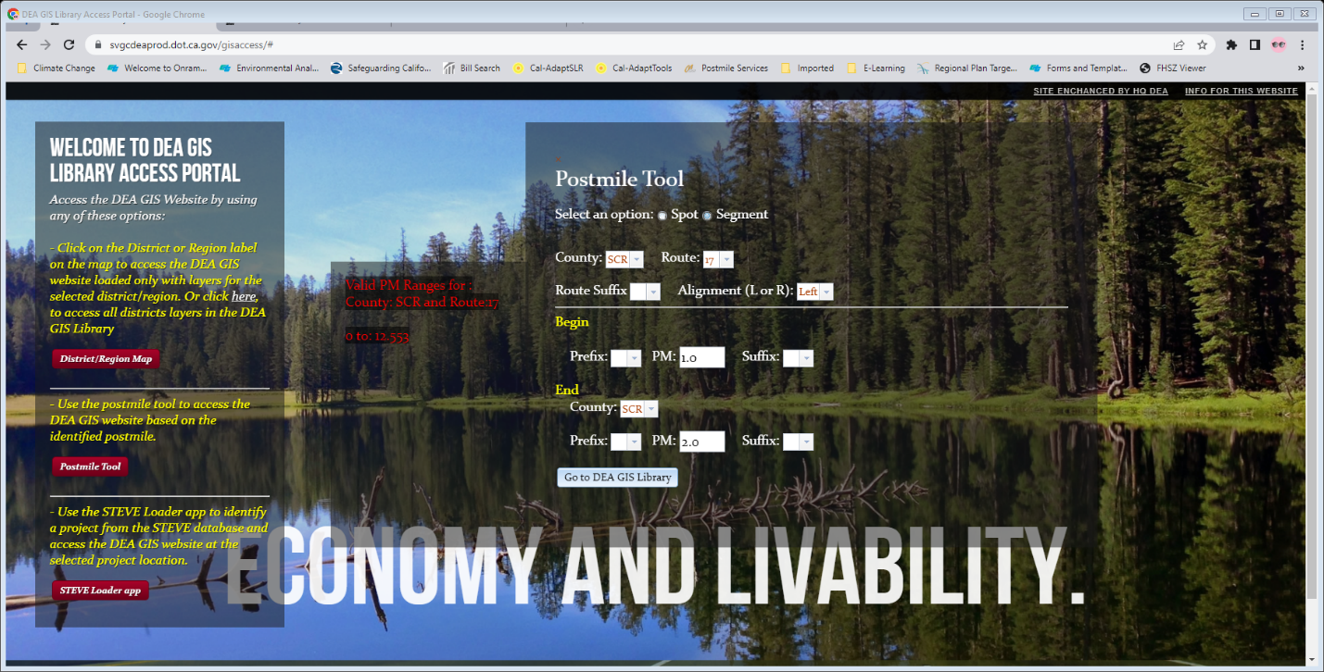
- Your route will display on the map.
- Select layers from the GIS Library menus: Climate tab. Select CosMos SLR or other data source appropriate to the project location.
- Select the highest SLR value in the menu. It may take a few moments for the map to draw. (Figure SLR-2)
- Be sure to display the legend.
- Export the map or take a screen clipping and paste it into a Word document, with page set up as landscape, narrow margins. Place a caption in the header identifying the project title, route, postmiles, and EA number.
- Save as pdf in the project record, to support the statement that project is outside the coastal zone and not in an area subject to sea level rise.
Figure SLR-2
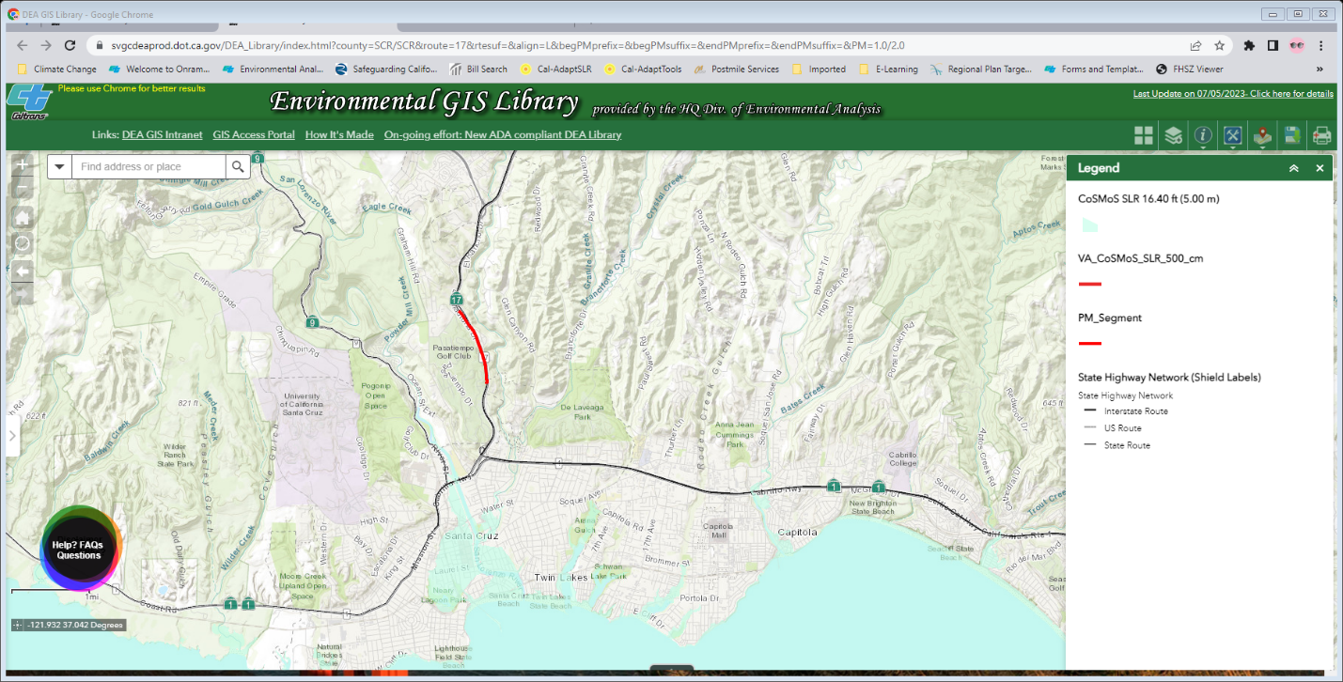
If the project is within the coastal zone (requiring approval of a coastal development permit, LCP amendment, or approval from the San Francisco Bay Conservation and Development Commission [BCDC]) or in a location subject to SLR (e.g., within the Sacramento-San Joaquin River Delta region or near the mouth of a tidally influenced river), an SLR analysis is required.
Ideally, if any of those conditions are met and an SLR analysis is required, sea level rise risks will have been analyzed and documented at the planning stage, an SLR study conducted, and adaptation options considered and incorporated into the project. In that case, report the findings of the study in the environmental document along with any measures or plans incorporated in the project to address the risks.
If an SLR analysis has not been previously completed for a project that is subject to sea level rise, conduct a simple risk assessment and bring your findings to the project manager and PDT as soon as possible. To determine the project’s potential exposure to sea level rise, do the following.
- Refer to the most recent State of California Sea Level Rise Guidance (Updating the State of California Sea-Level Rise Guidance Document – California Ocean Protection Council (OPC SLR Guidance). This guidance presents ranges of potential sea level rise under several different scenarios (Figure SLR-3).
  - Select the closest tide gauge location and refer to the table of sea level rise projections for that location.
  - Determine the project lifespan (design year and/or useful life of the project).
  - Using the tables in the OPC SLR Guidance, evaluate the risks to the project from the appropriate range of sea level rise projections.
  - Take notes or make a table with this project-specific information (Figure SLR-3).
Figure SLR-3
 | Intermediate Low | Intermediate | Intermediate High | High
2030 | 0.3 | 0.3 | 0.4 | 0.4
2040 | 0.4 | 0.5 | 0.6 | 0.7
2050 | 0.6 | 0.7 | 0.9 | 1.2
2060 | 0.7 | 1.0 | 1.4 | 1.9
2070 | 0.9 | 1.3 | 2.1 | 2.8
2080 | 1.0 | 1.7 | 2.9 | 3.9
2090 | 1.2 | 2.3 | 3.7 | 5.2
2100 | 1.4 | 2.9 | 4.6 | 6.4
2110 | 1.6 | 3.6 | 5.5 | 7.7
2120 | 1.8 | 4.2 | 6.2 | 8.8
2130 | 1.9 | 4.7 | 6.8 | 9.7
2140 | 2.1 | 5.2 | 7.3 | 10.6
2150 | 2.3 | 5.7 | 7.9 | 11.5

- Follow the steps above (for establishing whether the project is vulnerable to sea level rise) using the DEA GIS Library or other tool to map each of the sea level rise heights you identified using the projections in the OPC SLR Guidance for the project design life, potential useful life, 2050, and 2100. (The design life is the year until which the project is engineered to perform before reaching performance thresholds. Maintenance and planned upgrades can often extend an asset’s full life and should be considered given long-term climate change.) Do this for each year under each appropriate sea level rise scenario (Intermediate-Low, Intermediate, Intermediate-High, and High. If a project lifespan extends to 2100 or beyond, also consider the High 83rd percentile scenario.)
  - While the 2018 OPC SLR Guidance is still in effect, visualize and evaluate the Low, Medium-High, and Extreme risk aversion scenarios using the high emissions data in the 2018 tables.
- Export the maps or capture screen shots of each visualization and paste into a Word document.
- Export, print, or pdf the maps for the project record as described above. For projects subject to SLR effects, it is recommended that a jpg or similar format be included in the environmental document for illustration.
- Examine the maps to assess the extent and type of risks that sea level rise poses to the project. Consider:
  - What might be the consequences be for the Caltrans facility under each scenario? For example: temporary or permanent inundation, detours, short-term closure, long-term closure, obstruction of a critical emergency route?
  - When would such effects be expected to occur? For example: Bridge Number 00000 would be flooded or inundated at 1.9 feet of sea level rise, which could occur by 2050. With 100-year storm surge, flooding could occur as early as 2040. In this event, a detour of X miles would be required for the duration of the closure.
  - Project location: is the roadway out of harm’s way on a bluff high above high water? Protected by other infrastructure between the coast and the roadway?
  - Would the bluff be subject to erosion from wave run-up or storm surge that could eventually undermine the roadway?
  - How would users be affected? Is there a bike lane or housing that would be affected?
  - Consider the effects of disruptions on disadvantaged communities.
- Search the environmental document or resource studies for project features and avoidance, minimization, or mitigation measures that would address any of the identified risks. For example, does the project already include a sea wall or other barrier, elevated roadway, or natural infrastructure (perhaps as a component of biological resource AMMs) that would reduce the risk? Also consider non-structural solutions; for example, can maintenance practices be improved, such as by increasing frequency of culvert and drain clean outs?
- Research local programs for sea level rise adaptation. Local governments, coastal programs, community groups, or non-governmental organizations may have complementary projects or hazard mitigation plans that Caltrans can support to mitigate risk to the project.
- Bring this information to the project manager and PDT for further risk analysis as soon as possible.
- If it is infeasible to incorporate new protective features at the PA&ED stage, discuss developing an adaptive management plan for the project area or vulnerable corridor. Adaptive management solutions can be planned for implementation in future projects as certain triggers in time or conditions (such as increases in flood frequency) occur.
- In the sea level rise portion of the Adaptation section of the environmental document, describe the identified sea level rise scenarios, risks, timing, and project features and other proposed solutions. Describe how the project will be adapted or resilient during its design life. If the decision was to take no action in this project, describe adaption planning and what conditions would trigger future actions.
You may consult with your HQ Climate Change Representative or District Climate Change subject matter expert for examples of relevant analyses.
Additional Guidance for Projects within the Coastal Zone
In order to most effectively address coastal issues early in the project development process, be sure to review SER Volume 5: Coastal Requirements (https://dot.ca.gov/‌programs/‌environmental-analysis/‌standard-environmental-reference-ser/‌volume-5-coastal-requirements), for Coastal Hazards Policies (Coastal Act Sections 30253, 30236, and 30235). Refer to the Caltrans Coastal Policy Resource Checklist at the same webpage to identify and address typical use restrictions, common concerns addressed through coastal development review, and common technical study requirements.
For projects located within the coastal zone, address the following hazards specific to coastal areas:
- Beach areas subject to seasonal or long-term erosion
- Wave action and areas subject to high waves, such as those from storms, surges and seiches
- Coastal or riverine flood hazards
- Tsunamis and tsunami inundation run-up areas
- Sea level rise, from both a short- and long-term perspective
- Beach nourishment/sand supply for beaches vulnerable to wave damage and erosion. The loss of sediment and sand supply to the beach and the near-shore environment should be considered in the hazards assessment, as it could result in damaging effects such as an increase in hazards due to increased erosion and subsequent damage from waves.
Please note that not all projects will require the additional studies noted above, so early coordination with the CCC is critical to determine when such studies are appropriate and to avoid lengthy project delays.
For additional information on how to address potential California Coastal Act considerations related to climate change, greenhouse gas emissions, and future sea level rise, see the SER Vol. 5. Also see the California Coastal Commission’s Sea Level Rise Policy Guidance Document, updated and adopted November 7, 2018, and 2021’s Critical Infrastructure at Risk: Sea Level Rise Planning Guidance for California’s Coastal Zone. These reports and other useful information can be found on the Coastal Commission’s website https://www.coastal.ca.gov/climate/slr/.
Hydraulics analysts can refer to FHWA publication HEC-25, Highways in the Coastal Environment: Assessing Extreme Events: 3rd edition (2020), online at Publications - Hydraulics - Bridges & Structures - Federal Highway Administration (dot.gov).

Precipitation and Flooding
Climate change analyses for bridge and culvert projects in floodplains both inside and outside the coastal zone, and any projects adjacent to or over water, should consider the risk of changed precipitation patterns under climate change. Historical data is no longer a reliable predictor of future conditions. Changes in precipitation scenarios under future climate conditions include more-extreme precipitation events and more precipitation falling as rain than snow, depending on geographic location. These factors and others, such as land use changes that increase impervious surface in the watershed, can affect flood magnitude and frequency. Raise these considerations early at PDT meetings so Hydraulics, Design, Maintenance, and other functions can be involved. Assessing and accounting for these effects in design decisions such as elevation and materials selection can build resilience into projects. Alert Hydraulics to assess how changing climate conditions could affect the project. Guidance can be found in the FHWA 2016 publication Highways in the River Environment–Floodplains, Extreme Events, Risk, and Resilience, Hydraulic Engineering Circular No. 17, 2nd Edition at https://www.fhwa.dot.gov/engineering/hydraulics/library_‌arc.cfm? ‌pub_number=2&id=162. Also see California’s Fourth Climate Change Assessment (https://www.climateassessment.ca.gov/) technical report Projected Changes in California’s Precipitation Intensity-Duration-Frequency Curves, 20180827-ProjectionsPrecip_CCCA4-CEC-2018-005 at https://www.climateassessment.ca.gov/techreports/projections-datasets.html.

Wildfire
Determine if the project is in a location vulnerable to wildfire. Assess vulnerability using CalFire’s Fire Hazard Severity Zone mapping tool at https://egis.fire.ca.gov/FHSZ/ or the DEA GIS Library. Also consult District climate change vulnerability assessments and interactive mapping tool, which map miles of exposed roadway in each district. (https://dot.ca.gov/programs/transportation-planning/division-of-transportation-planning/air-quality-and-climate-change/2019-climate-change-vulnerability-assessments). Remember that wildfire combined with heavier precipitation events can lead to flash floods and mudslides that can severely impact the highway system. Describe what project features or measures will protect the project. Examples include culverts of steel or concrete instead of PVC, steel guardrail posts instead of wooden, defensible space cleared of vegetation around facilities. Consult Maintenance for fire-safe measures they may implement during operations, such as vegetation control. Mention the construction contract Standard Specification for Fire Prevention.

Temperature
Temperature affects choice of pavement materials, design of foundations and retaining walls in terms of ground moisture conditions, and need for expansion/contraction of bridge joints. During operations and maintenance, higher temperatures will affect safety of employees working outdoors, survival of landscaping and vegetation in right-of-way, and pavement condition, which could require more frequent maintenance. The Caltrans Climate Change Vulnerability Assessments only analyzed the effect of temperature on the choice of pavement binders. If the project area is projected to experience substantial change in maximum or minimum temperatures over the project design life, describe the pavement and maintenance choices that will increase the project’s resilience to temperature effects.
The temperature analysis may not be necessary for every project or district if the vulnerability assessments don’t anticipate heat or cold extremes. For such cases only, you may state:
The District Climate Change Vulnerability Assessment does not indicate temperature changes during the project’s design life that would require adaptive changes in pavement design or maintenance practices.

References
Add to your document’s references section. Reformat per your document references style, as needed.
California Air Resources Board (ARB). 2008. Climate Change Scoping Plan Appendices. Volume II: Analysis and Documentation. Appendix I, p. I-19. December. https://ww3.arb.ca.gov/cc/scopingplan/document/scopingplandocument.htm. Accessed: November 13, 2023.
California Air Resources Board (ARB). 2021. SB 375 Regional Plan Climate Targets. https://ww2.arb.ca.gov/our-work/programs/sustainable-communities-program/regional-plan-targets. Accessed: November 13, 2023.
California Air Resources Board (ARB). 2022a. California Greenhouse Gas Emissions Inventory Data–2022 Edition, 2000-2020. https://ww2.arb.ca.gov/ghg-inventory-data. Accessed: November 13, 2023.
California Air Resources Board (ARB). 2022b. 2022 Scoping Plan for Achieving Carbon Neutrality. Executive Summary. https://ww2.arb.ca.gov/our-work/programs/ab-32-climate-change-scoping-plan/2022-scoping-plan-documents. Accessed: November 13, 2023.
California Air Resources Board (ARB). 2022c. Climate Change. https://ww2.arb.ca.gov/our-work/topics/climate-change. Accessed: November 13, 2023.
California Department of Transportation (Caltrans). 201#. Caltrans Climate Change Vulnerability Assessments. District # Technical Report. December. Prepared by WSP. https://dot.ca.gov/programs/transportation-planning/2019-climate-change-vulnerability-assessments. [Revise publication year and month and District number as needed. Only include if you have referenced this report. Modify the reference District number, publication year, and month (if shown on the tech report cover) for your District. If there is no month on the cover, delete “December.”]
California Department of Transportation (Caltrans). 2020. Caltrans Greenhouse Gas Emissions and Mitigation Report. Final. August. Prepared by ICF, Sacramento, CA. https://dot.ca.gov/programs/public-affairs/mile-marker/summer-2021/ghg. Accessed: November 13, 2023.
California Department of Transportation (Caltrans). 2021a. California Transportation Plan 2050. February. https://dot.ca.gov/programs/transportation-planning/division-of-transportation-planning/state-planning-equity-and-engagement/california-transportation-plan. Accessed: November 13, 2023.
California Department of Transportation (Caltrans). 2021b. Caltrans 2020-2024 Strategic Plan. https://storymaps.arcgis.com/stories/‌f190b9755a184b268719dac9a11153f7. Accessed: November 13, 20233.
California Department of Transportation. 2023. Sustainable Operations at Caltrans. https://dot.ca.gov/programs/esta/sustainable-caltrans. Accessed: November 13, 2023.
California Governor’s Office of Planning and Research (OPR). 2015. A Strategy for California @ 50 Million. November. https://opr.ca.gov/planning/environmental-goals/. Accessed: November 13, 2023.
California Natural Resources Agency. 2022. Nature-Based Climate Solutions: Natural and Working Lands Climate Smart Strategy. https://resources.ca.gov/Initiatives/‌Expanding-Nature-Based-Solutions. Accessed: November 13, 2023.
California Natural Resources Agency. 2023. California Climate Adaptation Strategy. https://resources.ca.gov/Initiatives/Building-Climate-Resilience/2021-State-Adaptation-Strategy-Update. Accessed: November 13, 2023.
California Ocean Protection Council. 2022. State Agency Sea-Level Rise Action Plan for California. February. https://www.opc.ca.gov/climate-change/sea-level-rise-2/. Accessed: November 13, 2023.
California State Transportation Agency. 2021. Climate Action Plan for Transportation Infrastructure (CAPTI). https://calsta.ca.gov/subject-areas/climate-action-plan. Accessed: November 13, 2023.
Climate-Safe Infrastructure Working Group. 2018. Paying it Forward: The Path Toward Climate-Safe Infrastructure in California. September. https://resources.ca.gov/CNRALegacyFiles/docs/climate/ab2800/AB2800_Climate-SafeInfrastructure_FinalNoAppendices.pdf. Accessed: November 13, 2023.
Federal Highway Administration (FHWA). 2022. Sustainability. https://www.fhwa.dot.gov/environment/sustainability/resilience/. Last updated July 29, 2022. Accessed: November 13, 2023.
Federal Highway Administration (FHWA). No date. Sustainable Highways Initiative. https://www.fhwa.dot.gov/environment/sustainability/initiative/. Accessed: November 13, 2023.
National Oceanic and Atmospheric Administration (NOAA). 2022. 2022 Sea Level Rise Technical Report. https://oceanservice.noaa.gov/hazards/sealevelrise/‌sealevelrise-tech-report.html. Accessed: November 13, 2023.
State of California. 2018. California’s Fourth Climate Change Assessment. http://www.climateassessment.ca.gov/. Accessed: November 13, 2023.
U.S. Department of Transportation (U.S. DOT). 2014. Corporate Average Fuel Economy (CAFE) Standards. https://www.transportation.gov/mission/sustainability/corporate-average-fuel-economy-cafe-standards. Accessed: November 13, 2023.
U.S. Department of Transportation. 2023. Climate Action. January. https://www.transportation.gov/priorities/climate-and-sustainability/climate-action. Accessed: November 13, 2023.
U.S. Environmental Protection Agency (U.S. EPA). 2021. Final Rule to Revise Existing National GHG Emissions Standards for Passenger Cars and Light Trucks Through Model Year 2026. December. https://www.epa.gov/regulations-emissions-vehicles-and-engines/final-rule-revise-existing-national-ghg-emissions. Accessed: November 13, 2023.
U.S. Environmental Protection Agency. 2023a. Data Highlights. Inventory of U.S. Greenhouse Gas Emissions and Sinks: 1990-2021. https://www.epa.gov/ghgemissions/inventory-us-greenhouse-gas-emissions-and-sinks. Accessed: November 13, 2023.
U.S. Environmental Protection Agency. 2023b. Inventory of U.S. Greenhouse Gas Emissions and Sinks: 1990-2021. https://www.epa.gov/ghgemissions/inventory-us-greenhouse-gas-emissions-and-sinks. Accessed: November 13, 2023.
U.S. Global Change Research Program. 2023. Fifth National Climate Assessment. https://nca2023.globalchange.gov/chapter/front-matter/. Accessed: November 21, 2023.

