Implementation and Guidance of 23 CFR 667 – Periodic Evaluation of Facilities Repeatedly Requiring Repair and Reconstruction Due to Emergency Events

# INTRODUCTION:

Each State, acting through its department of transportation (State DOT), shall conduct statewide evaluations to determine if there are reasonable alternatives to roads, highways, and bridges that have required repair and reconstruction activities on two or more occasions due to emergency events and to determine if reasonable alternatives exist to address the root cause of recurring disaster damage requiring repeated repairs. (23 CFR 667.1)

The 23 CFR 667 requirement is a federal regulation mandating state and local agencies to conduct periodic evaluations of their transportation facilities that have been repeatedly damaged by emergency events, such as natural disasters or catastrophic failures.

# Background

The regulation enacting resiliency requirements to federal projects was enacted in 2016 as part of the Moving Ahead for Progress in the 21st Century Act (MAP-21) and applies to facilities on the National Highway System (NHS). The FAST Act then supplemented the MAP-21 resiliency requirements with added provisions to protect critical transportation infrastructure to projects on the federal-aid roadway system. The result of these two Acts is codified in the Code of Federal Regulations under 23 CFR 667.

# Purpose

The purpose of project evaluations on the federal-aid roadway system is to ensure local agencies managing federal-aid roads with locations of repeated disaster damage are identifying and considering reasonable alternatives to their project scopes that may reduce the need for future repairs, protect public safety, protect the environment, while still meeting their transportation needs.

The California Department of Transportation (Caltrans) create and maintain the Sites of Repeated Disaster Damage (SORDD) table and the subsequent 23 CFR 667 Resiliency Evaluation Certification on federally funded projects. Caltrans maintains the SORRD table, which is located on the Division of Local Assistance (DLA) Emergency Relief (ER) program web page. The table is updated after every ER eligible disaster event, to determine if any new locations should be added to the table. A minimum of once, every four years, the entire table is reviewed and updated as needed.

Note that “repeatedly damaged facilities” are roads, highways, and bridges that have required repair and reconstruction activities on two or more occasions due to natural disasters or catastrophic failures resulting in emergencies declared by the Governor of the State or the President (23 CFR 667.1). For purposes of 23 CFR part 667 evaluations, a catastrophic failure is a sudden failure of a major element or segment of a road, highway, or bridge due to an external cause (23 CFR 667.3). The failure must not be primarily attributable to gradual and progressive deterioration or lack of proper maintenance (23 CFR 667.3). A list of 23 CFR 667.3 definitions is provided for the reader in the Appendix located at the end of this document.

# Three-Step Procedure

Achieving compliance with 23 CFR 667 involves a streamlined three-step procedure, outlined below (see also Figure 1 in the Appendix).

1. Evaluate - Conduct an initial assessment of the proposed project to identify any sites with repeated disaster damage.
   1. If repeated disaster damage sites are present within the project limits, explore reasonable alternatives to address the root cause.
   2. If no such sites are identified, no further alternatives need to be considered.
2. Document - Record the evaluation process, including the consideration of alternatives if applicable. Maintain this documentation in the project folder for reference.
3. Report - Be prepared to furnish this documentation to FHWA and Caltrans upon request. FHWA conducts regular reviews and reports to Congress on this compliance requirement.

These steps must be completed for all FHWA federal-aid projects before:

* The Metropolitan Planning Organization (MPO) includes the project's Right-of-Way (RW) and Construction (CON) phases in the Federal Transportation Improvement Program (FTIP)/Federal State Transportation Improvement Program (FSTIP).
* Caltrans authorizes federal funding for the project's RW and CON phases.

Each step is described in more detail below:

1. **Evaluate**

Evaluation involves determining if there are repeated disaster damage sites within the proposed project limits by cross-referencing the project location with the Sites Of Repeated Disaster Damage (SORDD) list. If such sites are found, explore reasonable alternatives to address the root cause of the repeated damage.

The 23 CFR 667 regulation requires the evaluation and consideration of alternatives to be completed before the following project milestones are reached:

• National Environmental Policy Act (NEPA) process completion.

• Selection of the project’s “preferred alternative.”

• Authorization of federal funding for Right-of-Way (RW) and Construction (CON) phases of work.

In evaluating the project, agencies are encouraged to consider using a Benefit-Cost (B-C) Analysis. Links to FHWA templates and guidance for the FHWA Discretionary programs are provided below, which may be used for this purpose. Keep in mind, the 23 CFR 667 requirement is to consider alternatives, and implementation is not mandatory. It is important to adequately document the evaluation and consideration of alternatives effort, so it can be later shown the project complied with 23 CFR 667.

1. **Document**

Once the Evaluation is completed, it is important to retain documentation of the Evaluation and result in the project files. This shows FHWA, and other auditing agencies, the project followed the process and thus complies with the 23 CFR 667 requirements. These documents may be required by the MPO or Rural RTPA before they program the project's Right-of-Way (RW) and Construction (CON) phases into the FTIP/FSTIP, as required by 23 CFR 667. Please note, failure to provide adequate documentation for compliance with the 23 CFR 667 Resiliency Requirements may result in loss of federal funding for the project.

1. **Report**

Per 23 CFR 667, FHWA will conduct periodic reviews of the 23 CFR 667 compliance on local agency, RTPA, and MPO projects.

For this reason, it is essential that administering agencies (i.e., local agencies, MPOs, and rural RTPAs, as applicable) of federally funded projects located on the federal-aid roadway system maintain documentation that would demonstrate project compliance with 23 CFR 667 requirements. This documentation must be maintained and provided, upon request, to FHWA and Caltrans.

FHWA will use the information requested as part of their compliance review and assessment, which is required under 23 CFR 667.9(b). The FHWA review encompasses evaluating performance, considering results during project development, and overall project outcomes. Regular audits ensure ongoing compliance. Non-compliance with this regulation could result in loss of federal funds for the delinquent project and may inhibit the local agency's ability to secure federal funds for future FHWA funded projects.

# Limited Exceptions

All federally funded road and bridge projects must comply with the 23 CFR 667 Resiliency requirements, with only a few limited exceptions. Theses exceptions are:

1. Road and bridge projects on a Federally Owned (FO) or Tribe owned roadway (FO roads are typically owned and maintained by a federal agency; examples include, but are not limited to, the U.S. Forest Service, U.S. Bureau of Reclamation, etc.).
2. Emergency Opening repairs (EO) on Emergency Relief (ER) funded projects. (ER program project’s Permanent Repairs being administered under the regular ER process are not exempt from the 23 CFR 667 Requirement).

The Permanent Repair (PR) portion of ER projects is not exempt and must comply with 23 CFR 667 requirements. Although ER projects are exempt from the FTIP/FSTIP programming requirement, ER projects must still comply with 23 CFR 667 prior to completing NEPA document, selecting a preferred alternative, and receiving federal funding for the PR RW and CON phases of work. If you have any questions on whether an ER project is exempt from the 23 CFR 667 process, please contact your assigned District Local Assistance Engineer (DLAE).

*Figures*

# Figure 1. Process Flow Chart

The below flow chart briefly outlines the general sequence of events to be followed for 23 CFR 667 compliance.

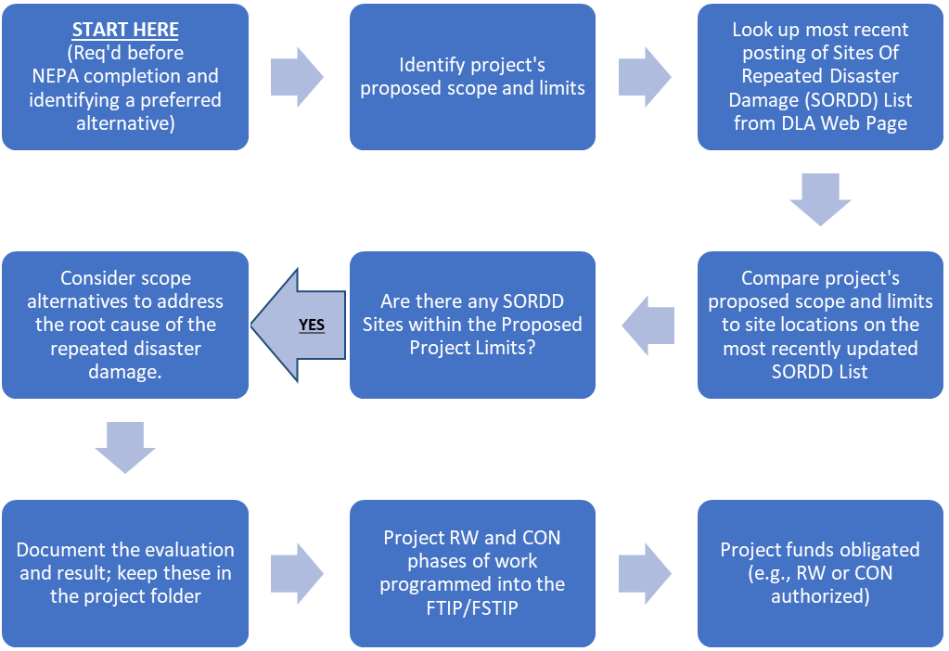

NO

Appendix

# 23 CFR 667.3 Definitions

The following definitions are from 23 CFR 667.3 that are to be used in the application of 23 CFR 667. These definitions are provided here as a reference for the reader:

**Catastrophic Failure** means the sudden failure of a major element or segment of a road, highway, or bridge due to an external cause. The failure must not be primarily attributable to gradual and progressive deterioration or lack of proper maintenance.

**Evaluation** means an analysis that includes identification and consideration of any alternative that will mitigate, or partially or fully resolve, the root cause of the recurring damage, the costs of achieving the solution, and the likely duration of the solution. The evaluations shall consider the risk of recurring damage and cost of future repair under current and future environmental conditions. These considerations typically are a part of the planning and project development process.

**Emergency Event** means a natural disaster or catastrophic failure resulting in an emergency declared by the Governor of the State or an emergency or disaster declared by the President of the United States.

**Reasonable Alternatives** include options that could partially or fully achieve the following:

1. Reduce the need for Federal funds to be expended on emergency repair and reconstruction activities;
2. Better protect public safety and health and the human and natural environment; and
3. Meet transportation needs as described in the relevant and applicable Federal, State, local, and tribal plans and programs. Relevant and applicable plans and programs include the Long-Range Statewide Transportation Plan, Statewide Transportation Improvement Plan (STIP), Metropolitan Transportation Plan(s), and Transportation Improvement Program(s) (TIP) that are developed under part 450 of this title.

**Repair and Reconstruction** means work on a road, highway, or bridge that has one or more reconstruction elements. The term includes permanent repairs such as restoring pavement surfaces, reconstructing damaged bridges and culverts, and replacing highway appurtenances, but excludes emergency repairs as defined in 23 CFR 668.103.

**Roads, Highways, and Bridges** means a highway, as defined in 23 U.S.C. 101(a)(11), that is open to the public and eligible for financial assistance under title 23, U.S.C.; but excludes tribally owned and federally owned roads, highways, and bridges.